Exercise – 8 Implementing Basic AOP with Spring

Name: Shubham Sangram Bej

Aim
To implement basic Aspect-Oriented Programming (AOP) in Spring for separating cross-cutting concerns, such as logging from the business logic of the Library Management application.

Scenario
The Library Management application requires basic AOP functionality to separate cross-cutting concerns like logging and transaction management from the core business logic.

Objective
- Understand the concept of Spring AOP.
- Create an Aspect class.
- Implement Before Advice.
- Implement After Advice.
- Configure AspectJ Auto Proxy.
- Verify logging using Spring AOP.

Software Requirements
- Java JDK 21
- Apache Maven
- Spring Framework 5.3.39
- Spring AOP
- AspectJ Weaver
- IntelliJ IDEA

Theory
Aspect-Oriented Programming (AOP) is a programming paradigm that separates cross-cutting concerns such as logging, security, exception handling, and transaction management from the main business logic of an application.
Spring AOP allows developers to modularise these concerns using aspects. An Aspect is a class that contains advice methods. Advice defines what action should be performed before, after, or around a method execution. A Join Point represents a specific point during program execution, while a Pointcut specifies the join points where advice should be applied.
In this exercise, a LoggingAspect class is created to log messages before and after the execution of the service method. The aspect is configured in applicationContext.xml, and AspectJ auto-proxying is enabled so that Spring automatically applies the logging functionality without modifying the business logic.

Procedure
- Created a Maven project.
- Added Spring Context, Spring AOP, and AspectJ Weaver dependencies.
- Created the BookRepository class.
- Created the BookService class.
- Created the LoggingAspect class.
- Implemented Before Advice.
- Implemented After Advice.
- Configured the aspect in applicationContext.xml.
- Enabled AspectJ Auto Proxy.
- Created the LibraryManagementApplication class.
- Loaded the Spring IoC Container.
- Executed the application and verified AOP functionality.

Files Used
- BookRepository.java
- BookService.java
- LoggingAspect.java
- LibraryManagementApplication.java
- applicationContext.xml
- pom.xml

Output

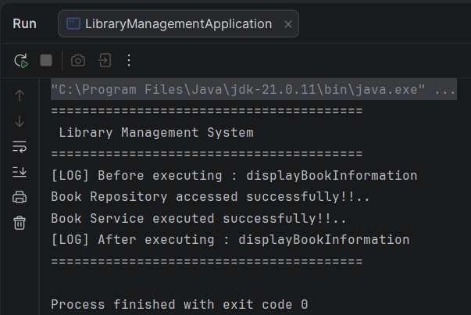

Screenshots
- Project Structure
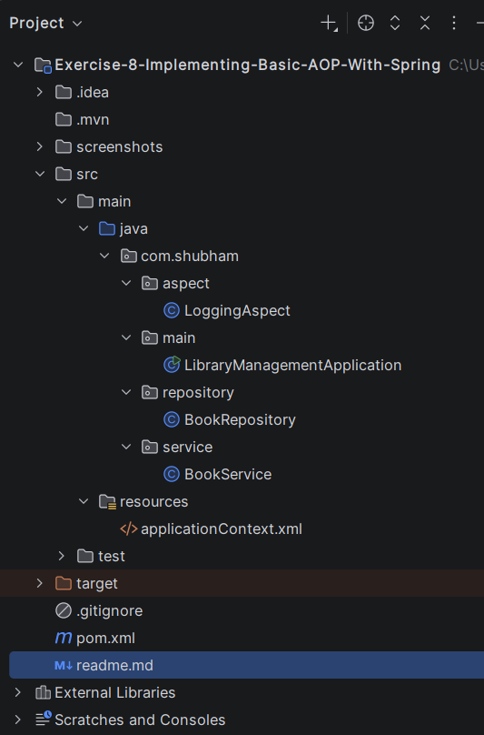
- pom.xml
<?xml version="1.0" encoding="UTF-8"?>
<project xmlns="http://maven.apache.org/POM/4.0.0"
xmlns:xsi="http://www.w3.org/2001/XMLSchema-instance"
xsi:schemaLocation="
http://maven.apache.org/POM/4.0.0
https://maven.apache.org/xsd/maven-4.0.0.xsd">
<modelVersion>4.0.0</modelVersion>
<groupId>com.shubham</groupId>
<artifactId>exercise-8-implementing-basic-aop-with-spring</artifactId>
<version>1.0-SNAPSHOT</version>
<properties>
<maven.compiler.source>21</maven.compiler.source>
<maven.compiler.target>21</maven.compiler.target>
<spring.version>5.3.39</spring.version>
</properties>
<dependencies>
<dependency>
<groupId>org.springframework</groupId>
<artifactId>spring-context</artifactId>
<version>${spring.version}</version>
</dependency>
<dependency>
<groupId>org.springframework</groupId>
<artifactId>spring-aop</artifactId>
<version>${spring.version}</version>
</dependency>
<dependency>
<groupId>org.aspectj</groupId>
<artifactId>aspectjweaver</artifactId>
<version>1.9.22</version>
</dependency>
</dependencies>
</project>

- BookRepository.java
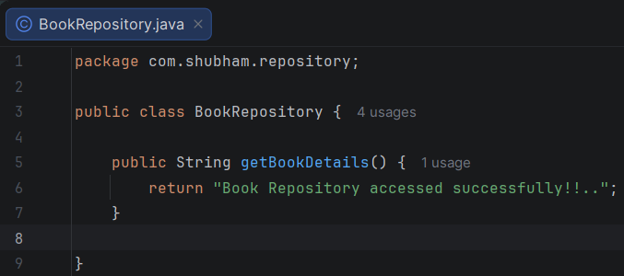

- BookService.java
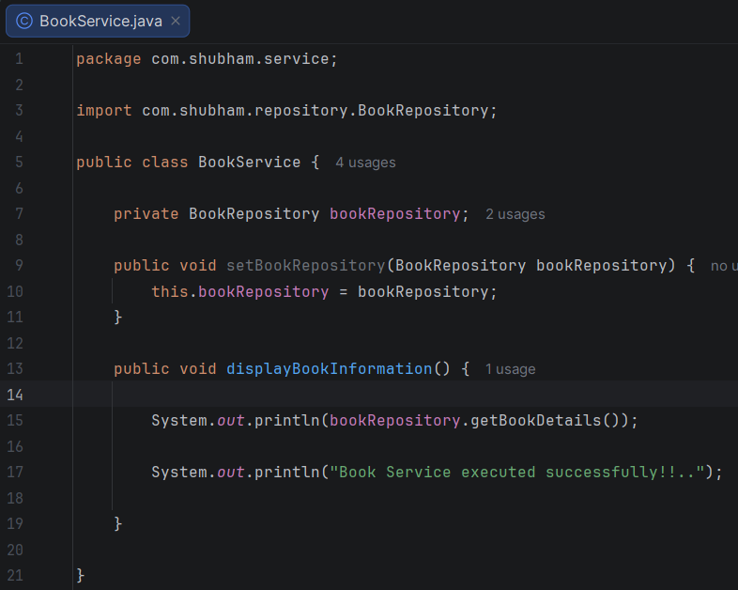

- LoggingAspect.java
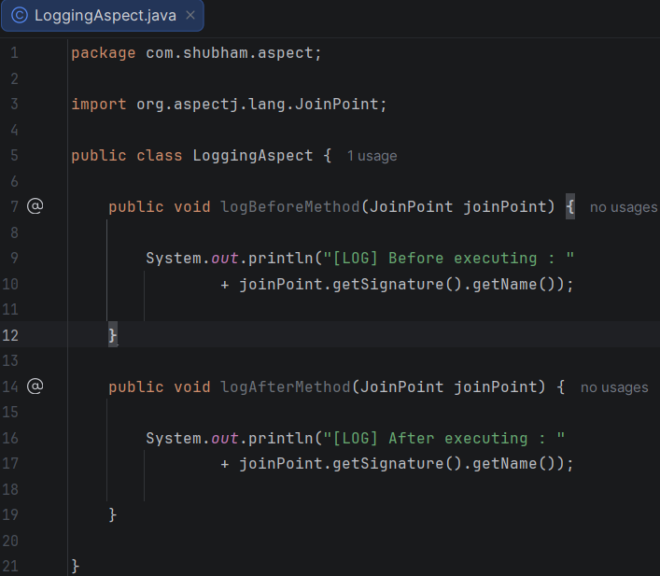

- applicationContext.xml
<?xml version="1.0" encoding="UTF-8"?>
<beans xmlns="http://www.springframework.org/schema/beans"
xmlns:xsi="http://www.w3.org/2001/XMLSchema-instance"
xmlns:aop="http://www.springframework.org/schema/aop"
xsi:schemaLocation="
http://www.springframework.org/schema/beans
https://www.springframework.org/schema/beans/spring-beans.xsd
http://www.springframework.org/schema/aop
https://www.springframework.org/schema/aop/spring-aop.xsd">
<bean id="bookRepository"
class="com.shubham.repository.BookRepository"/>
<bean id="bookService"
class="com.shubham.service.BookService">
<property
name="bookRepository"
ref="bookRepository"/>
</bean>
<bean id="loggingAspect"
class="com.shubham.aspect.LoggingAspect"/>
<aop:aspectj-autoproxy/>
<aop:config>
<aop:aspect ref="loggingAspect">
<aop:before
method="logBeforeMethod"
pointcut="execution(* com.shubham.service.*.*(..))"/>
<aop:after
method="logAfterMethod"
pointcut="execution(* com.shubham.service.*.*(..))"/>
</aop:aspect>
</aop:config>
</beans>

- LibraryManagementApplication.java
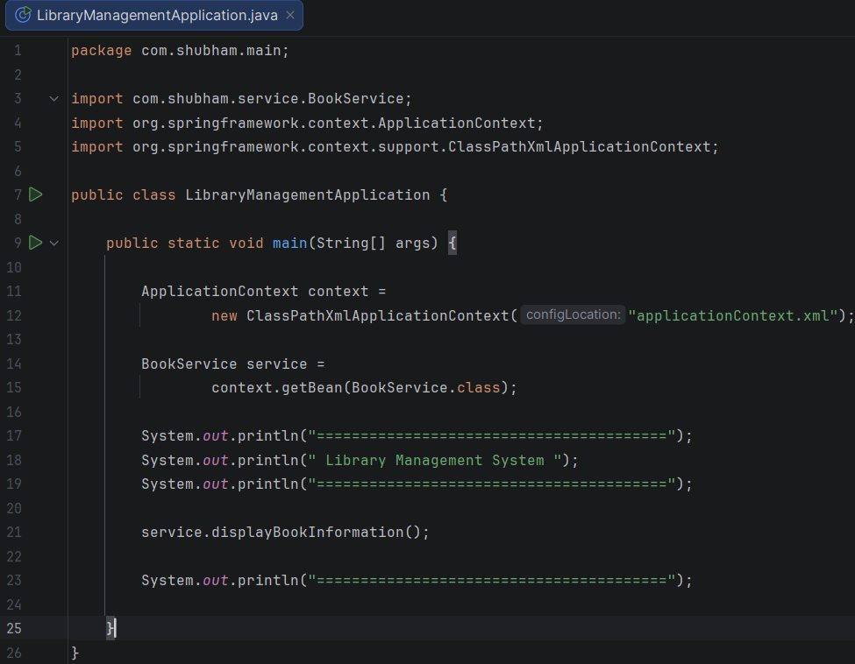

Result
The Spring AOP functionality was successfully implemented using a logging aspect. The application executed the Before and After advice automatically around the service method, demonstrating the separation of cross-cutting concerns from the business logic.

Conclusion
This exercise demonstrated the implementation of Spring AOP using XML configuration. The logging functionality was successfully separated from the application logic through the use of aspects, advice methods, and AspectJ auto-proxying, resulting in a modular and maintainable application.

